**Abstract: -**

I chose Animating Scalable Vector Graphics (SVG) within a responsive website as one of my portfolio briefs because I wanted to understand how SVG’s were used on the web.

For my SVG images I used Illustrator, as I am very comfortable with creating images and path etc.

From my research, I found out most websites used mostly SVG rather than Bitmap image formats for the web— Which comprises of PNG, WBMP, JPEG and GIF, these formats however describe images using a grid of pixels which results in the files being too be bulky, or limited to a lower resolution, which tend to take up large amounts of bandwidth on the web. (Helpx.adobe.com, 2018)

SVG on the other hand is solely XML based which I could use with JavaScript to create Web graphics, which is vector format, and provide high quality web graphics which according to (Helpx.adobe.com, 2018) would respond to a user “actions with sophisticated effects such as highlighting, tooltips, audio, and animation”.

The research gave me a better understanding of how SVG work, how to create one and what tools were available to used in creating an SVG for web.

This pictorial essay would describe the step-step process in which I used in accomplishing the brief.

The essay would also show I used JavaScript, CSS and Data Driven Document (D3) to animate the extracted SVG code from Illustrator.

SVG’s have had an increased usage on the web the past few years’ reasons being that SVG is a vector format that describes images as shapes, paths, text, and filter effects.

The files produced are high quality graphics that can be used on the web and works well on hand held devices. Which could be scaled to whichever resolution without loosing its quality.

Considering “**mobile first**” as most smart devices come in different screen resolutions and sizes SVG are widely used by web developers to combat that problem.

Firstly in order to create an SVG file, I used Illustrator, to design the entire image and saved as an svg file. Then I copied the svg code which illustrator generates for my text editor, which I would further explain in this essay.

“The SVG format is entirely XML-based and offers many advantages to developers and users alike. With SVG, you can use XML and JavaScript to create web graphics that respond to user actions with sophisticated effects such as highlighting, tooltips, audio, and animation”.

**Introduction**

As a web developer and designer I always research what is new the market and try to update myself with the latest trend in terms of developing the web.

From my recent research I found out vector file format, recently found its way into the mainstream of web design as curious as I am I wanted to explore this new finding and study how SVG’s could be animated, resized and used as a company logos, illustrations animated illustration and so on.

The relevant skills I have in producing the brief is as follows:

* HTML5
* CSS
* JavaScript
* Good use of illustrator and canvas.

SVG files are XML-Based, which means they can be altered manually in a text editor and JavaScript or CSS can also be used to manipulate and modified the code within the XML file.

With a good understanding of HTML5 some CSS and JavaScript I started researching the many articles on the web about animating SVG.

And exploring many JavaScript libraries that actually animate SVG files.

I was working on a clients website and he mentioned that his logo was not scaling properly on mobile devices so after reviewing the website I realised his logo was a PNG format. Which I had changed to SVG and the image maintained its rich Svg format.

This is just to support my rationale for this project.

Images below:

 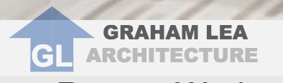

PNG- Logo SVG- Logo

SVG files are usually small in size and light weight and help with the performance of most websites, compared to other visual file formats.

Which I find very interesting, as most websites tend to work better than others in terms of performance

**Background:**

The idea behind my brief is to create SVG for web and to animate the SVG using either CSS or JavaScript.

The SVG should be embedded into an HTML file, which should be responsive; meaning should work across multiple devices.

(Cousins C, 2017) points out that small, simple animations are engaging and interesting; the user might not even think about their being an animation at all”.

Animations in Web are a very common trend in web development as there are many websites that uses some illustration, directions or instructions, using little animations such as SVG help serves as a hint for users, considering navigation on the specific website and to increase usability.

SVG’s is more like a guiding tool for users on a webpage and a good way in creating graphical images on a website and mobile application development as most mobile devices uses very high resolutions and SVG’s are vector graphic and are scalable.

(Oberoi S, 2016). States “SVG is an XML-based format that allows you to create an image by using defined tags and attributes. Your code will render an image that you can edit right in your code editor”.

All SVG files are written using XML. So SVG can be embedded in a web page as an SVG file or as a raw XLM code. (Rocheleau J, 2016).

**Exporting an SVGs From a Graphics Editor (Illustrator) And Optimizing Them**

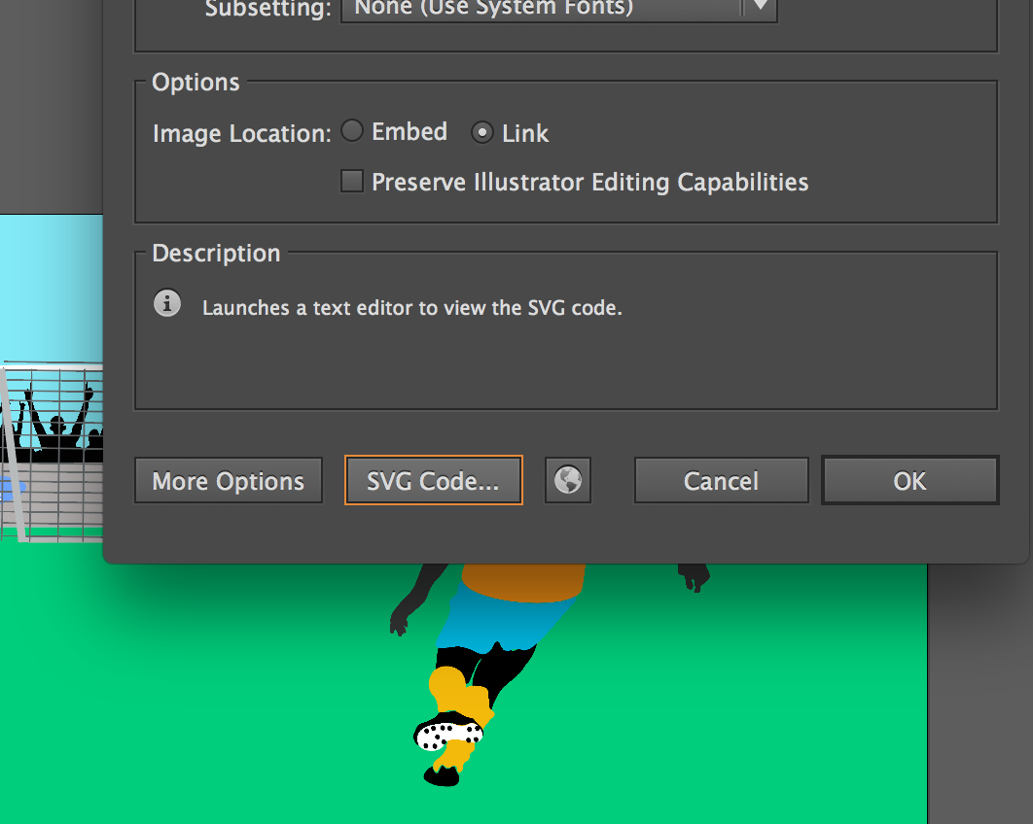

Once the image is drawn 🡪save as🡪 image location [link] 🡪then SVG code**..**

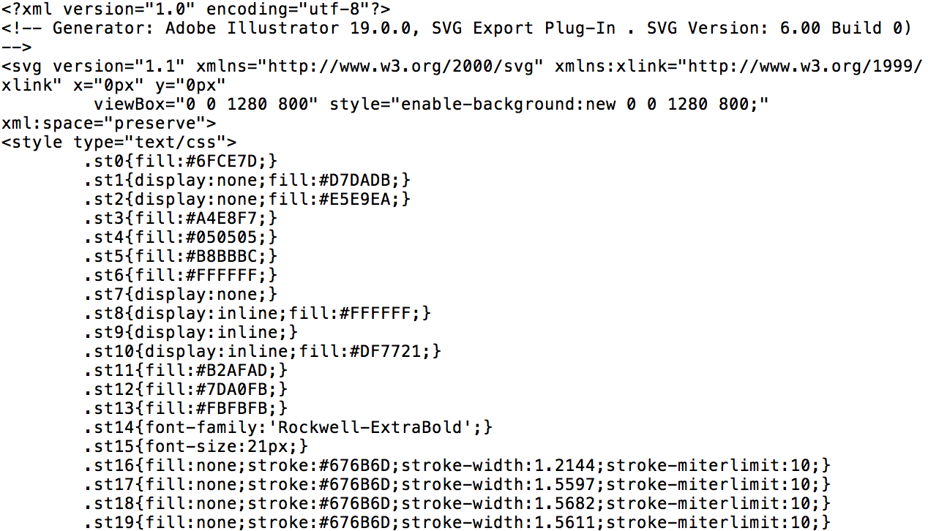

**Using CSS in manipulating SVG to animate**

CSS can be used to animate SVG, which includes using;

* Hover state
* Transforms
* And transitions. (Stack exchange, 2017).

(Coyier, 2018) argues that there is not one-way to animate SVG, “There is the <animate>tag that goes right into the SVG code. There are libraries that help with it like Snap.svg or SVG.js.”

SVG can be animate in different

**Body of Work:**

Design research

In researching Animated SVG examples on the web, I found many that came in different forms, and other relevant tools that can be used to animate SVG such as SVGator Snap.svg or GASP just to mention a few.

After researching I drafted a sketch of the responsive website and the images that am going to animate.

**IDEA#1:**

The first idea that came to my mind was a scene of the city with dirt bikes racing on the street.

I was looking at a more detailed and sophisticated animation that was more detailed, and not just buttons or logos. So I sketched out the first design on paper.

#1- Scene of the City

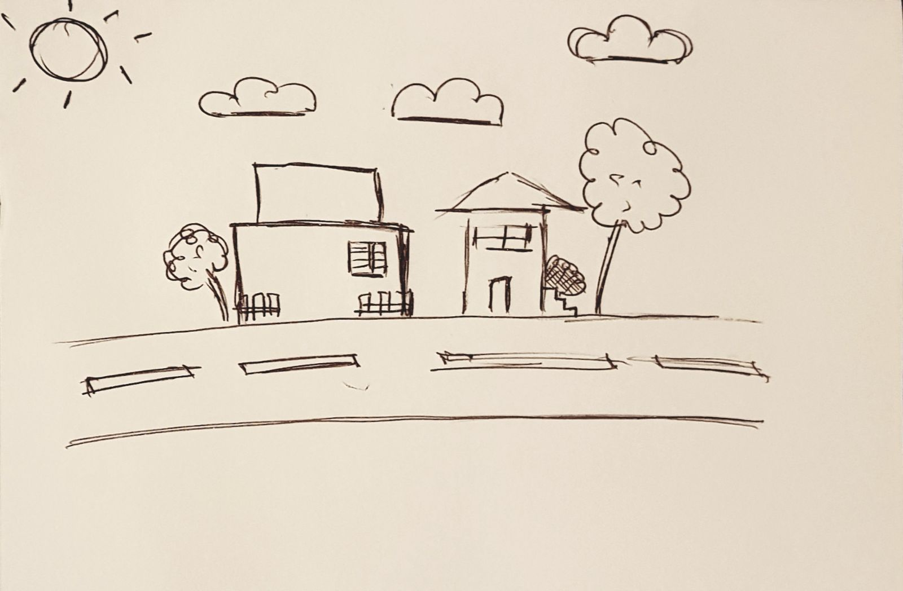

#2- Sketch of the Dirt Bike.

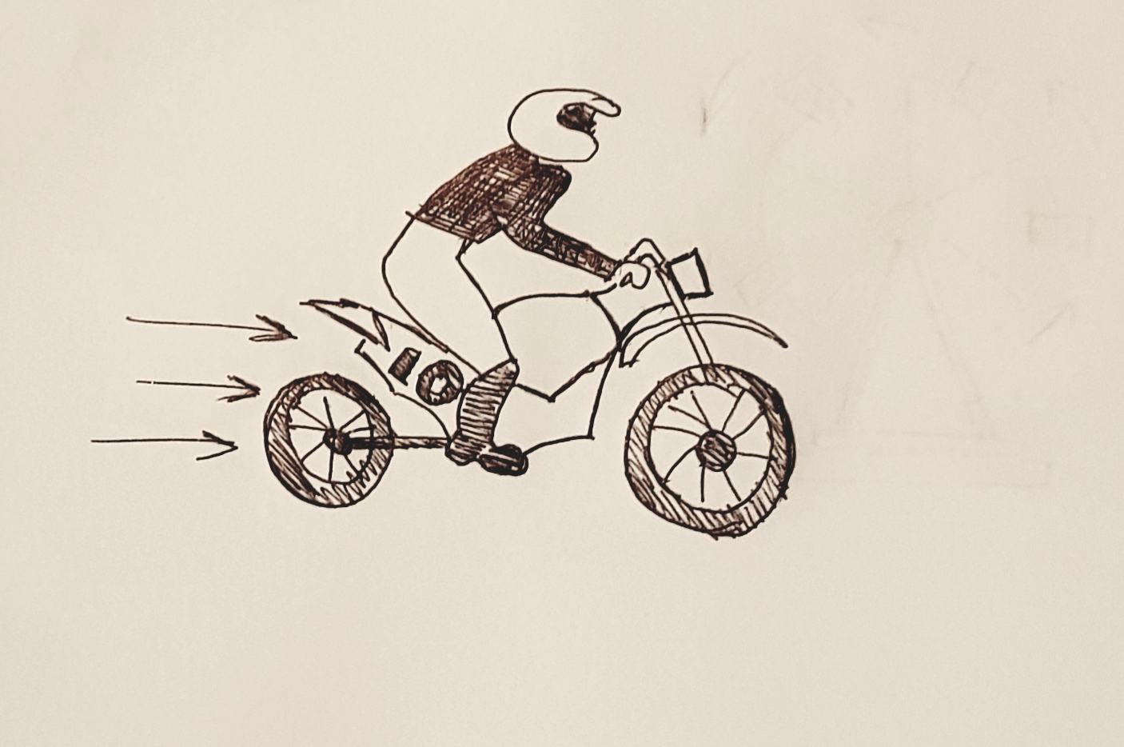

#3 - During my initial planning I had wanted to animate a roller coaster using CSS and a bit of JavaScript so I decide to add this thought to the scenery as it would fit perfectly. Below is a rough sketch.



#4 - The final Product would look more like this with a good amount of animations, which may bring the SVG to life..

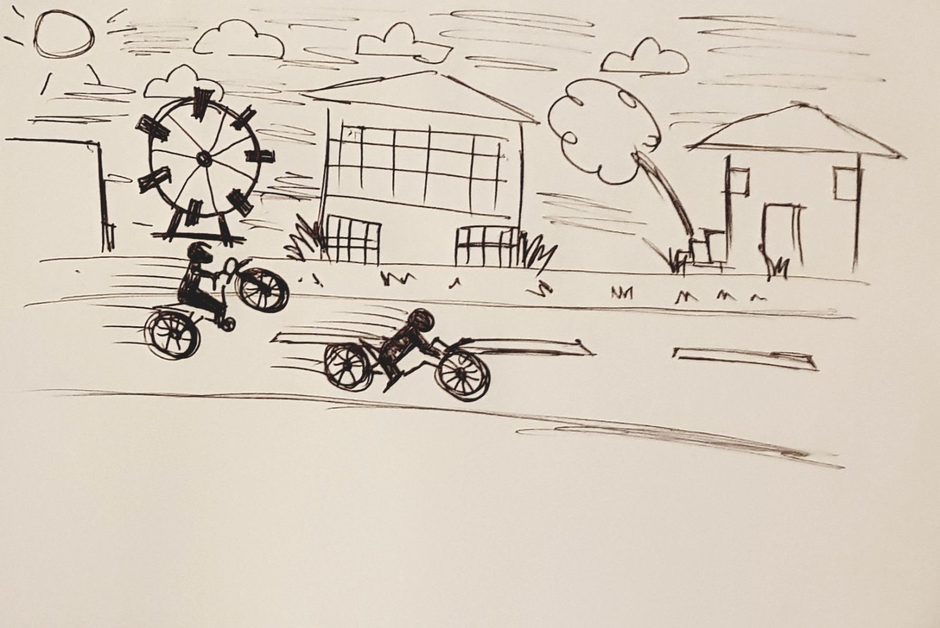

**IDEA#2**

My second idea was to use an svg image that I had created a year ago and try to animate the image using CSS or any available JavaScript library.

I idea was to have the image to either blink, once the page is loaded or when the user hovers on the image, the character in the image would raise his eyebrows.

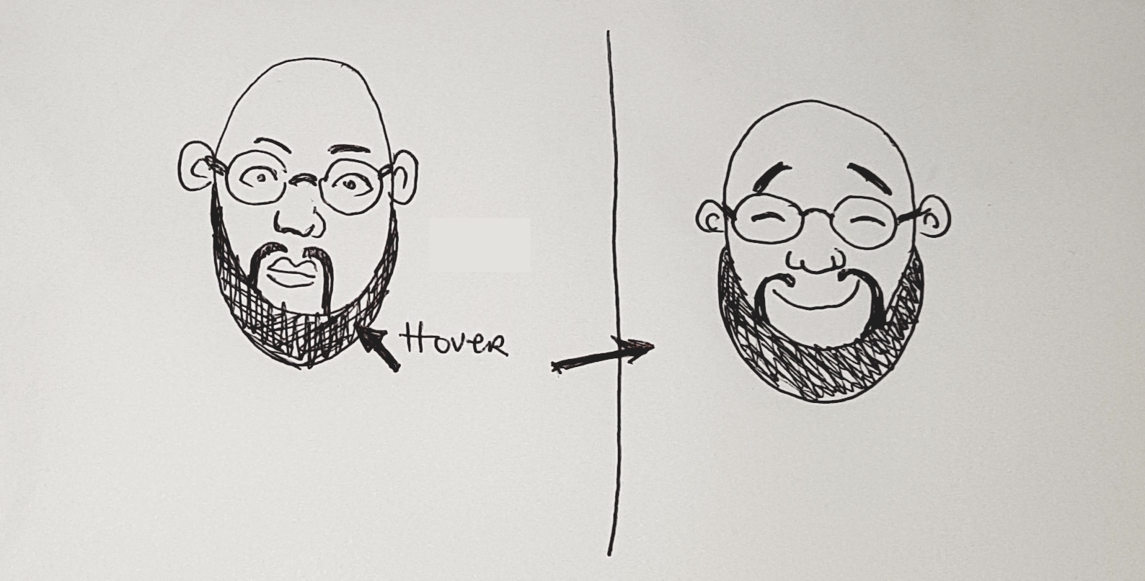

**IDEA#3**

My third idea was to use D3 to move an SVG object back and forth, then it dawned on my I could actually design a football kick off which I did.

I also did a rough sketch, which gave me an idea as to what I wanted to design in illustrator.

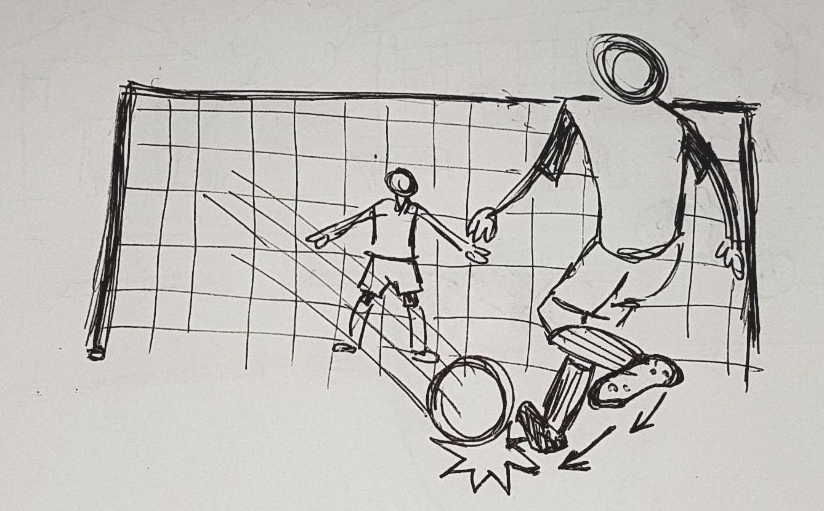

**Design**

**Idea#1-**

I started designing in Illustrator, started with rectangles and squares for the sky, street and lawn and then added colors to it as shown below:

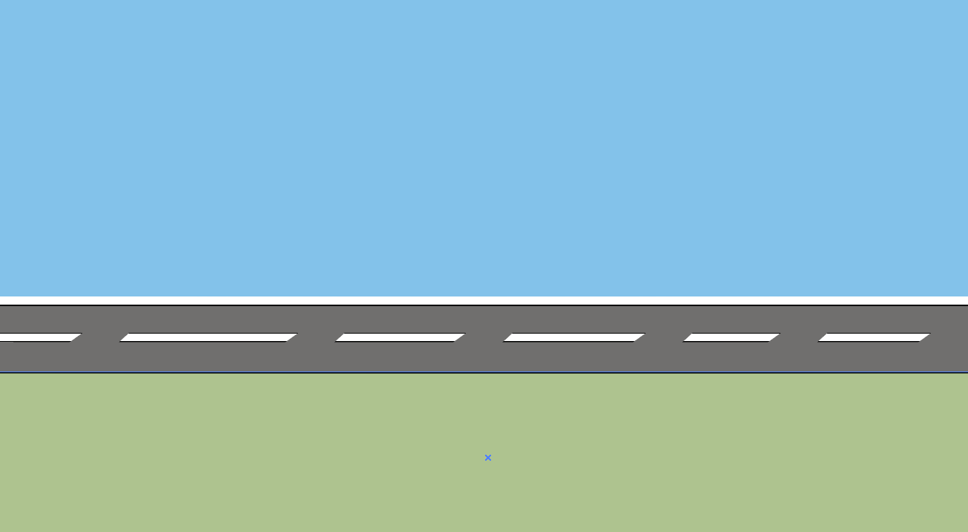

All images were designed using shapes.

The Dirt bikes were drawn and grouped as one with a unique name, which would be beneficial later on in the animation stages.

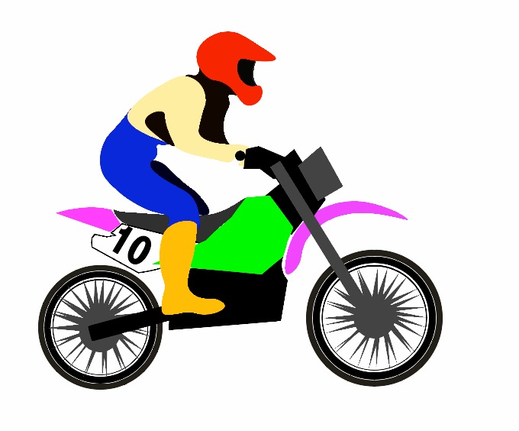

I duplicated the bike image and changed the colors to have more than one image of the bike.

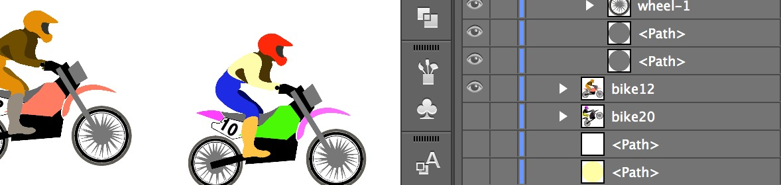

All the paths were grouped and given a unique name in the layers panel.

Once all images have been designed in Illustrator, I group all the images that are NOT going to be animated as one image and named so I could distinguish it from the ones that I would be animating.

Since I was going to animate the cloud, to move at a certain speed and location renamed it in the layers panel.

The plane, was also renamed in the layers panel

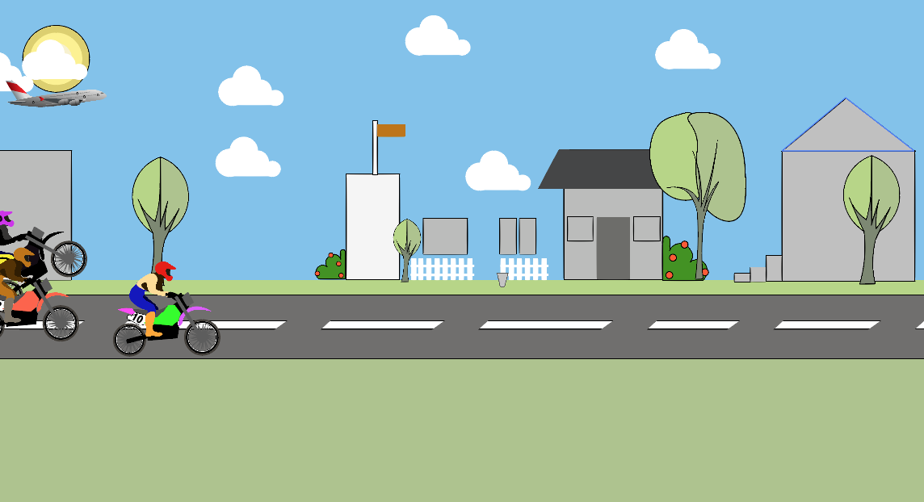

#Final design for IDEA#1

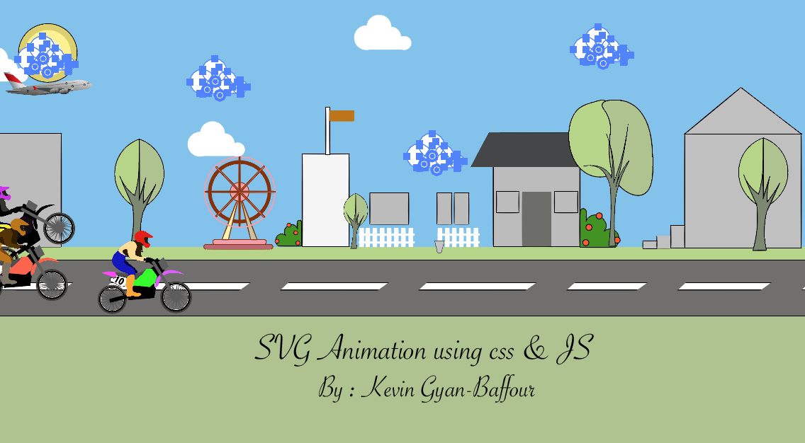

Once the Svg image was complete I saved the image as an svg and selected link tab, another windows pops up and shows the SVG code, which I copied into my text editor (sublime), where I had already created a responsive webpage.



Copying the code above generated from illustrator and pasting it into my text editor below.

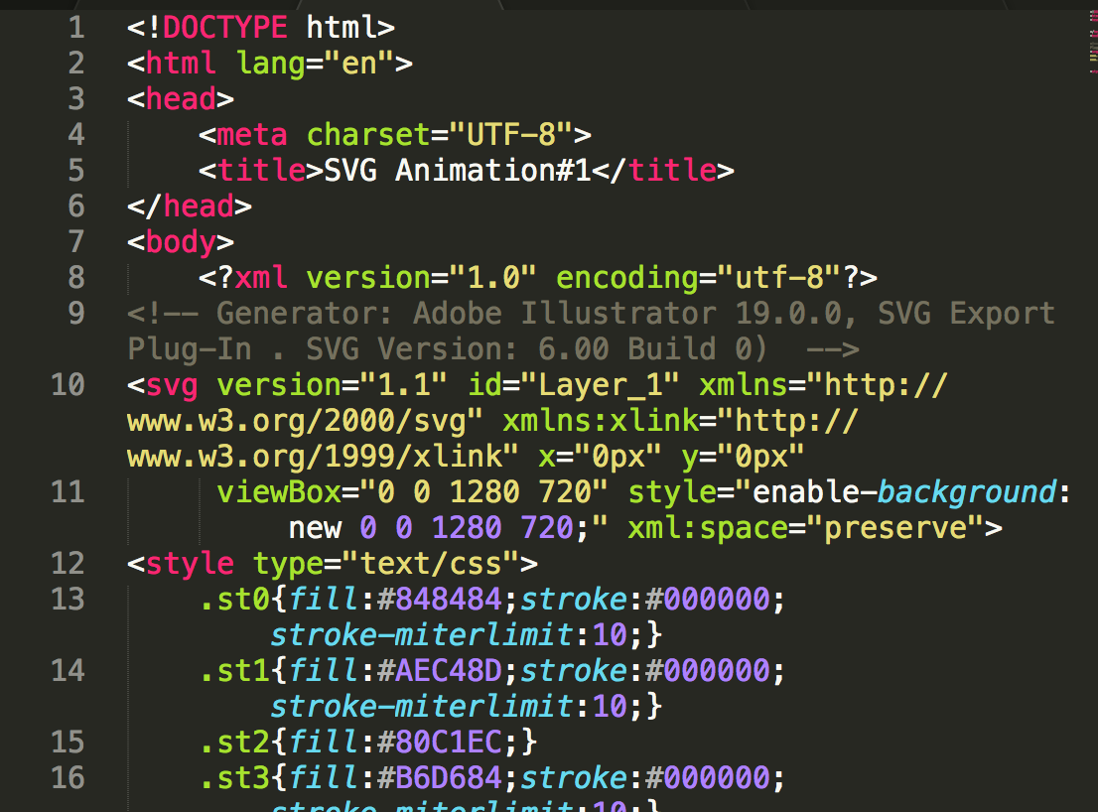

**Development**

In developing **idea # 1**, I started off with designing the roller coaster.

There are many other ways to animate SVG .I researched many other way such as using libraries that aid in animating SVG such as Snap.svg or perhaps svg.js.

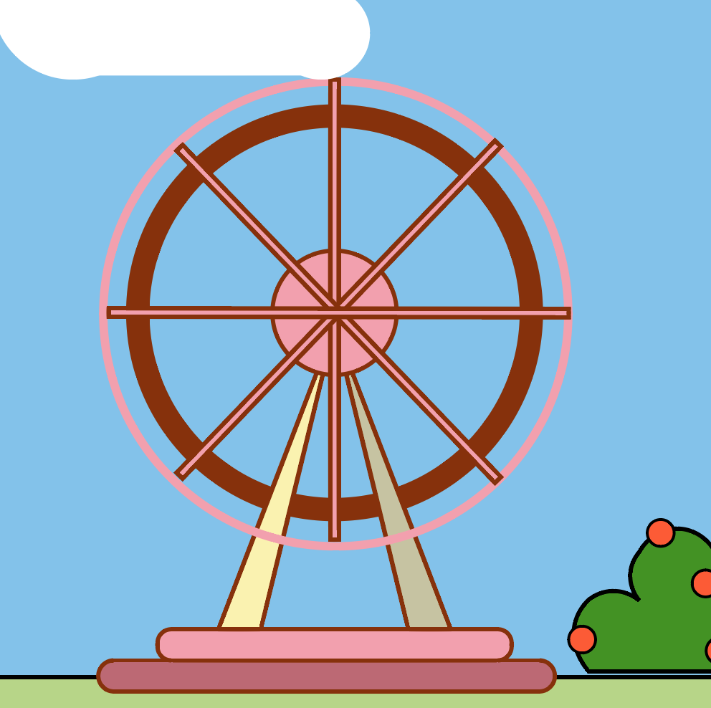

I then created a Cartesian coordinate system (with the y-axis flipped) for the animated square. That is, placing the origin at the center of the 800 x 800 SVG viewport.



This rotating circle was created as a standalone SVG.

Which I embedded into my HTML and used the <animate Transform> attribute to animated the image setting the duration from 0 to 360. And repeat Count attribute to Infinite.

The values of the repeat count attribute specify the number of iterations.

According to (MDN Web Docs, 2018) Repeat count can also include partial iterations expressed as fraction values. Its value must be greater than 0.

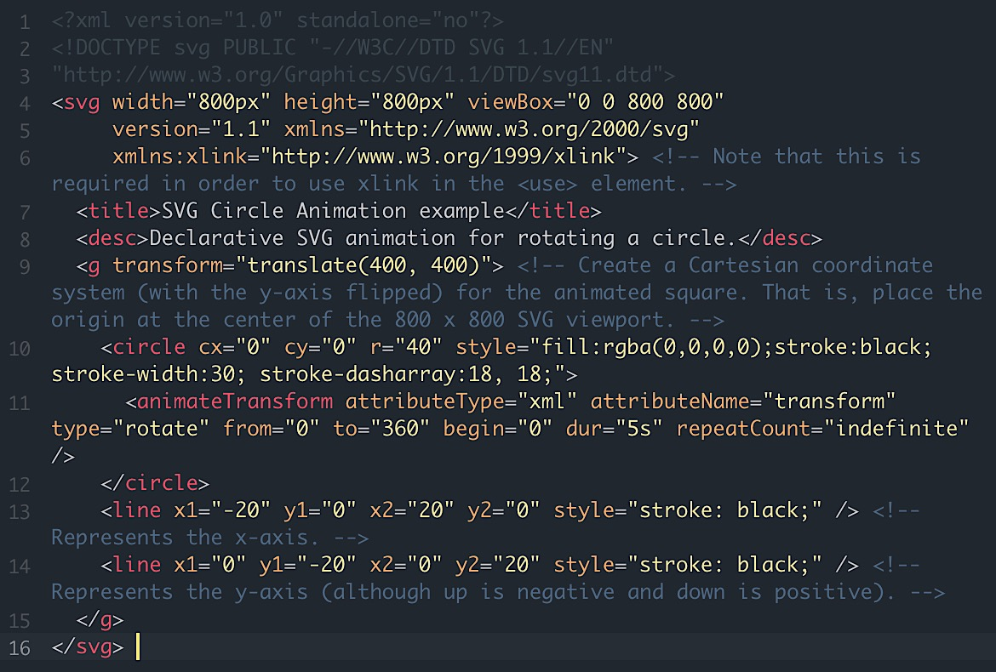

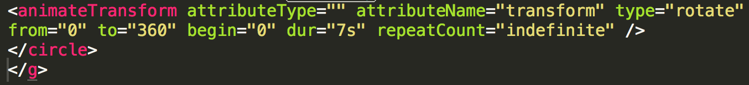

**Animating the Rollercoaster**

The CX and CY attribute which defines the x and y coordinates were both set to zero, which centers the rotating circle and positions the circle onto the svg rollercoaster.

I gave it a fill of: rgba (0,0,0,0), which made the circle transparent,

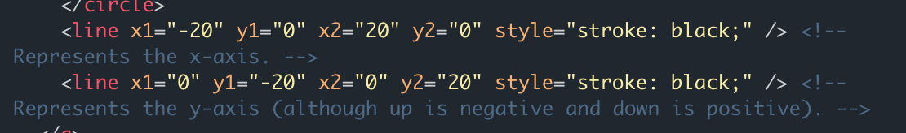



At the intersection where the x and y axis crosses was to demonstrate where the rotating circle was to be placed.

**idea # 2**

**User testing**

**Iteration**

**User testing**

**Methods**

**Researching-frameworks and libraries**

**Exploration into languages**

**Discussion and Conclusion**

**References:**

Helpx.adobe.com (2018) Work with SVG format in illustrator. [online]

Available at <https://helpx.adobe.com/illustrator/using/svg.html>

[Accessed 6th April 2018]

Rocheleau J. (2015). *Trends & Examples of SVG Animation in Web Design.* Available: <http://www.vandelaydesign.com/svg-animation-trends/>.

Last accessed [10th March 2018]

Coyier, C. (2018) Animating SVG with CSS|CSS-Tricks. [Online] CSS-Tricks.

Available at: <https://css-tricks.com/animating-svg-css/> [Accessed on 6th April 2018]

Oberoi S. (2016). How to Design, Code, and Animate *SVGs. Available*: <https://medium.freecodecamp.org/a-guide-to-svg-on-web-c5932dadca03>. Last accessed 13th March 2018.

Cousins C. (2017). An Introduction to Animation in Web Design. Available: <https://designshack.net/articles/graphics/an-introduction-to-animation-in-web-design/>. Last accessed 13th March 2018.

MDN Web Docs. (2018). *repeatCount*. [online] Available at: https://developer.mozilla.org/en-US/docs/Web/SVG/Attribute/repeatCount#Example [Accessed 9 Apr. 2018].